ER-модель БД

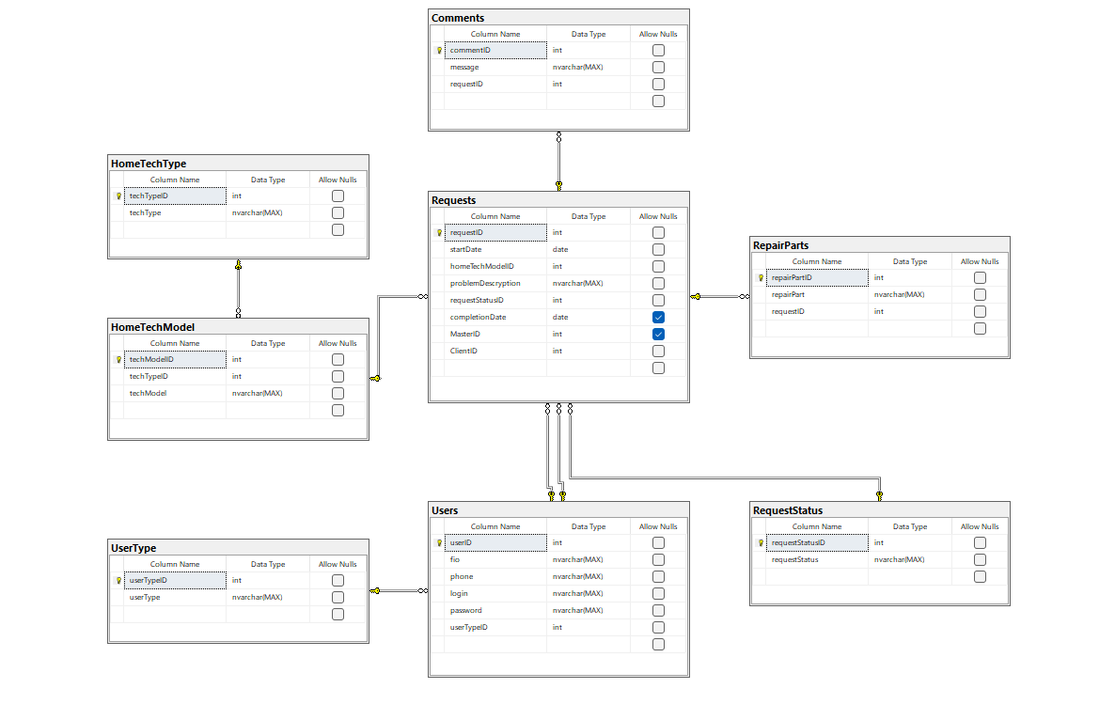

Словарь данных

Comments

|  |  |  |  |  |
| --- | --- | --- | --- | --- |
| KEY | Имя поля | Тип данных / Размер | Необходимо? | Примечания |
| PK | commentID | INTEGER | Y | Auto Increment |
|  | message | NVARCHAR(MAX) | Y |  |
| FK Requests | requestID | INTEGER | Y |  |

RepairParts

|  |  |  |  |  |
| --- | --- | --- | --- | --- |
| KEY | Имя поля | Тип данных / Размер | Необходимо? | Примечания |
| PK | repairPartID | INTEGER | Y | Auto Increment |
|  | repairPart | NVARCHAR(MAX) | Y |  |
| FK Requests | requestID | INTEGER | Y |  |

Requests

|  |  |  |  |  |
| --- | --- | --- | --- | --- |
| KEY | Имя поля | Тип данных / Размер | Необходимо? | Примечания |
| PK | repairPartID | INTEGER | Y | Auto Increment |
|  | startDate | DATE | Y |  |
|  | problemDescription | NVARCHAR(MAX) | Y |  |
|  | completionDate | DATE | N |  |
| FK RequestStatus | requestStatusID | INTEGER | Y |  |
| FK HomeTechModel | techModelID | INTEGER | Y |  |
| FK Users | masterID | INTEGER | N |  |
| FK Users | clientID | INTEGER | Y |  |

RequestStatus

|  |  |  |  |  |
| --- | --- | --- | --- | --- |
| KEY | Имя поля | Тип данных / Размер | Необходимо? | Примечания |
| PK | requestStatusID | INTEGER | Y | Auto Increment |
|  | requestStatus | NVARCHAR(MAX) | Y |  |

HomeTechModel

|  |  |  |  |  |
| --- | --- | --- | --- | --- |
| KEY | Имя поля | Тип данных / Размер | Необходимо? | Примечания |
| PK | techModelID | INTEGER | Y | Auto Increment |
|  | techModel | NVARCHAR(MAX) | Y |  |
| FK HomeTechType | techTypeID | INTEGER | Y |  |

HomeTechType

|  |  |  |  |  |
| --- | --- | --- | --- | --- |
| KEY | Имя поля | Тип данных / Размер | Необходимо? | Примечания |
| PK | techTypeID | INTEGER | Y | Auto Increment |
|  | techType | NVARCHAR(MAX) | Y |  |

Users

|  |  |  |  |  |
| --- | --- | --- | --- | --- |
| KEY | Имя поля | Тип данных / Размер | Необходимо? | Примечания |
| PK | userID | INTEGER | Y | Auto Increment |
|  | fio | NVARCHAR(MAX) | Y |  |
|  | phone | NVARCHAR(MAX) | Y |  |
|  | login | NVARCHAR(MAX) | Y |  |
|  | password | NVARCHAR(MAX) | Y |  |
| FK UserType | userTypeID | INTEGER | Y |  |

UserType

|  |  |  |  |  |
| --- | --- | --- | --- | --- |
| KEY | Имя поля | Тип данных / Размер | Необходимо? | Примечания |
| PK | userTypeID | INTEGER | Y | Auto Increment |
|  | userType | NVARCHAR(MAX) | Y |  |

Скрипт БД

CREATE TABLE UserType

(

userTypeID INT PRIMARY KEY IDENTITY(1,1) NOT NULL,

userType NVARCHAR(MAX) NOT NULL

)

CREATE TABLE Users

(

userID INT PRIMARY KEY IDENTITY(1,1) NOT NULL,

fio NVARCHAR(MAX) NOT NULL,

phone NVARCHAR(MAX) NOT NULL,

login NVARCHAR(MAX) NOT NULL,

password NVARCHAR(MAX) NOT NULL,

userTypeID INT NOT NULL REFERENCES UserType(userTypeID)

)

CREATE TABLE HomeTechType

(

techTypeID INT PRIMARY KEY IDENTITY(1,1) NOT NULL,

techType NVARCHAR(MAX) NOT NULL

)

CREATE TABLE HomeTechModel

(

techModelID INT PRIMARY KEY IDENTITY(1,1) NOT NULL,

techTypeID INT NOT NULL REFERENCES HomeTechType(techTypeID),

techModel NVARCHAR(MAX) NOT NULL

)

CREATE TABLE RequestStatus

(

requestStatusID INT PRIMARY KEY IDENTITY(1,1) NOT NULL,

requestStatus NVARCHAR(MAX) NOT NULL

)

CREATE TABLE RepairParts

(

repairPartID INT PRIMARY KEY IDENTITY(1,1) NOT NULL,

repairPart NVARCHAR(MAX) NOT NULL,

requestID INT NOT NULL REFERENCES Requests(requestID)

)

CREATE TABLE Requests

(

requestID INT PRIMARY KEY IDENTITY(1,1) NOT NULL,

startDate DATE NOT NULL,

homeTechModelID INT NOT NULL REFERENCES HomeTechModel(techModelID),

problemDescryption NVARCHAR(MAX) NOT NULL,

requestStatusID INT NOT NULL REFERENCES RequestStatus(requestStatusID),

completionDate DATE,

MasterID INT REFERENCES Users(userID),

ClientID INT NOT NULL REFERENCES Users(userID)

)

CREATE TABLE Comments

(

CommentID INT PRIMARY KEY IDENTITY(1,1) NOT NULL,

Message NVARCHAR(MAX) not null,

RequestID INT NOT NULL REFERENCES Request(requestID)

)

Резервное копирование

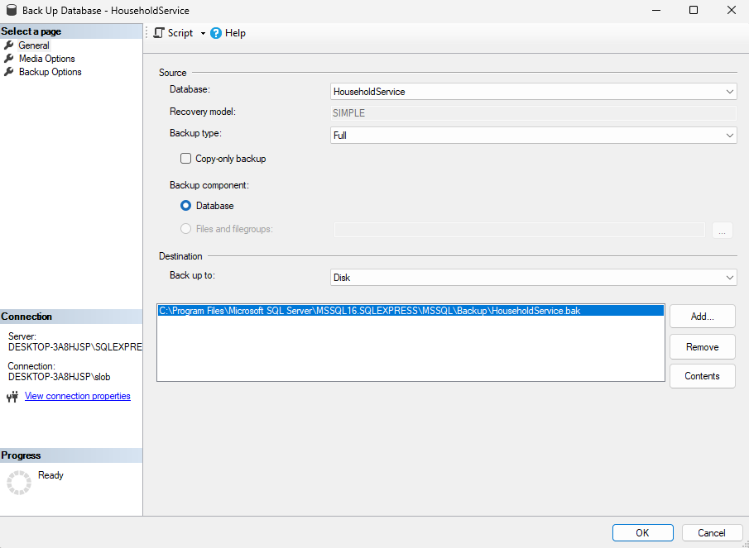

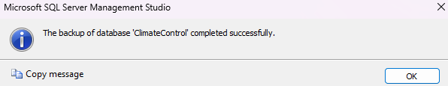

Таблица

Comments

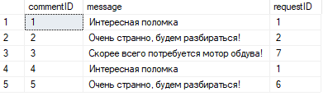

Requests

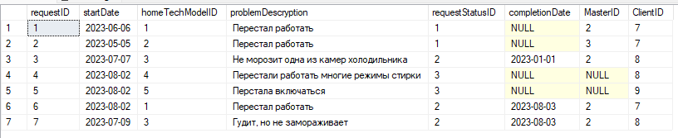

RequestStatus

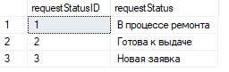

HomeTechModel

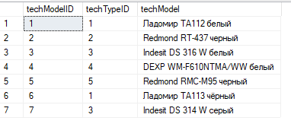

HomeTechType

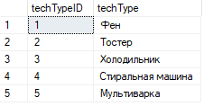

Users

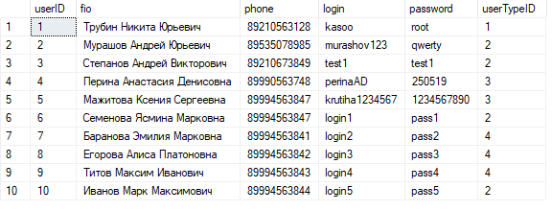

UserType

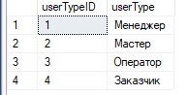

RepairParts

